|  |  |
| --- | --- |
| Report ID | Rpt001 |
| Title | Business Performance Dashboard |

**Design Layout:**

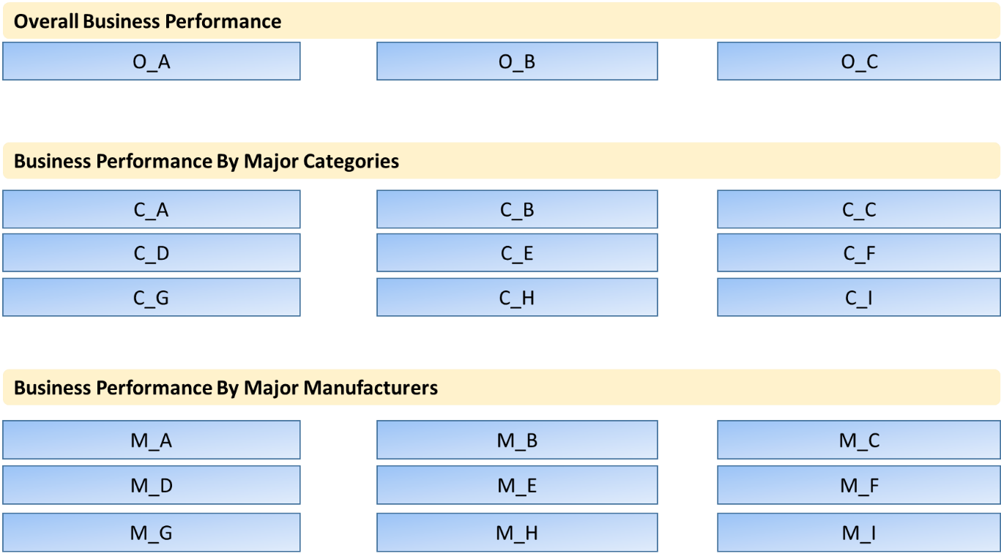

|  |  |
| --- | --- |
| **Display Area** | O_A |
| **Output** | Total Order Number |
| **Value Display Description** | Current update to date, total order number, for all categories.  Quantity of orders.  Not the sale numbers. |
| **Business Logic** | ttl_orders_no |
| **DB / Tables** | Tables: overall_dashboard |
| **Page Load Calc. / Pre-Calculate** | Pre-Calculate. |

|  |  |
| --- | --- |
| **Display Area** | O_B |
| **Output** | Total Sale Number (Prefix RM) |
| **Value Display Description** | Current update to date, total sales number, for all categories.  Sum of total sales for each transaction / orders.  Display in RM. Thousand comma separator. 2 decimal points. |
| **Business Logic** | ttl_sales_no |
| **DB / Tables** | Tables: overall_dashboard |
| **Page Load Calc. / Pre-Calculate** | Pre-Calculate. |

|  |  |
| --- | --- |
| **Display Area** | O_C |
| **Output** | Total Customer Number in business |
| **Value Display Description** | Current update to date, total unique customer number, for all categories. |
| **Business Logic** | ttl_customer_no |
| **DB / Tables** | Tables: overall_dashboard |
| **Page Load Calc. / Pre-Calculate** | Pre-Calculate. |

|  |  |
| --- | --- |
| **Display Area** | C_A |
| **Output** | Category: PRINTER  Total Order Number  Total Sale Number  Total Customer Number  that contains Category: PRINTER |
| **Value Display Description** | Refer to display area: O_A, O_B, O_C, but calculation focus on category: PRINTER. |
| **Business Logic** | ttl_orders_no_p  ttl_sales_no_p  ttl_customer_no_p |
| **DB / Tables** | Tables: overall_dashboard |
| **Page Load Calc. / Pre-Calculate** | Pre-Calculate. |

|  |  |
| --- | --- |
| **Display Area** | C_B |
| **Output** | Category: INK  Total Order Number  Total Sale Number  Total Customer Number  that contains Category: INK |
| **Value Display Description** | Refer to display area: O_A, O_B, O_C, but calculation focus on category: INK. |
| **Business Logic** | ttl_orders_no_i  ttl_sales_no_i  ttl_customer_no_i |
| **DB / Tables** | Tables: overall_dashboard |
| **Page Load Calc. / Pre-Calculate** | Pre-Calculate. |

|  |  |
| --- | --- |
| **Display Area** | C_C |
| **Output** | Category: TONER  Total Order Number  Total Sale Number  Total Customer Number  that contains Category: TONER |
| **Value Display Description** | Refer to display area: O_A, O_B, O_C, but calculation focus on category: TONER. |
| **Business Logic** | ttl_orders_no_t  ttl_sales_no_t  ttl_customer_no_t |
| **DB / Tables** | Tables: overall_dashboard |
| **Page Load Calc. / Pre-Calculate** | Pre-Calculate. |

|  |  |
| --- | --- |
| **Display Area** | C_D |
| **Output** | Category: PAPER  Total Order Number  Total Sale Number  Total Customer Number  that contains Category: PAPER |
| **Value Display Description** | Refer to display area: O_A, O_B, O_C, but calculation focus on category: PAPER. |
| **Business Logic** | ttl_orders_no_pa  ttl_sales_no_pa  ttl_customer_no_pa |
| **DB / Tables** | Tables: overall_dashboard |
| **Page Load Calc. / Pre-Calculate** | Pre-Calculate. |

|  |  |
| --- | --- |
| **Display Area** | C_E |
| **Output** | Category: TECHNOLOGY  Total Order Number  Total Sale Number  Total Customer Number  that contains Category: TECH |
| **Value Display Description** | Refer to display area: O_A, O_B, O_C, but calculation focus on category: TECHNOLOGY. |
| **Business Logic** | ttl_orders_no_tech  ttl_sales_no_tech  ttl_customer_no_tech |
| **DB / Tables** | Tables: overall_dashboard |
| **Page Load Calc. / Pre-Calculate** | Pre-Calculate. |

|  |  |
| --- | --- |
| **Display Area** | C_F |
| **Output** | Category: STATIONARY  Total Order Number  Total Sale Number  Total Customer Number  that contains Category: STATIONARY |
| **Value Display Description** | Refer to display area: O_A, O_B, O_C, but calculation focus on category: STATIONARY. |
| **Business Logic** | ttl_orders_no_s  ttl_sales_no_s  ttl_customer_no_s |
| **DB / Tables** | Tables: overall_dashboard |
| **Page Load Calc. / Pre-Calculate** | Pre-Calculate. |

|  |  |
| --- | --- |
| **Display Area** | C_G |
| **Output** | Category: OFFICE EQUIPMENT  Total Order Number  Total Sale Number  Total Customer Number  that contains Category: OFFICE EQUIPMENT |
| **Value Display Description** | Refer to display area: O_A, O_B, O_C, but calculation focus on category: OFFICE EQUIPMENT. |
| **Business Logic** | ttl_orders_no_oe  ttl_sales_no_oe  ttl_customer_no_oe |
| **DB / Tables** | Tables: overall_dashboard |
| **Page Load Calc. / Pre-Calculate** | Pre-Calculate. |

|  |  |
| --- | --- |
| **Display Area** | C_H |
| **Output** | Category: BREAKROOM  Total Order Number  Total Sale Number  Total Customer Number  that contains Category: BREAKROOM |
| **Value Display Description** | Refer to display area: O_A, O_B, O_C, but calculation focus on category: BREAKROOM. |
| **Business Logic** | ttl_orders_no_b  ttl_sales_no_b  ttl_customer_no_b |
| **DB / Tables** | Tables: overall_dashboard |
| **Page Load Calc. / Pre-Calculate** | Pre-Calculate. |

|  |  |
| --- | --- |
| **Display Area** | C_I |
| **Output** | Category: CLEANING  Total Order Number  Total Sale Number  Total Customer Number  that contains Category: CLEANING |
| **Value Display Description** | Refer to display area: O_A, O_B, O_C, but calculation focus on category: CLEANING. |
| **Business Logic** | ttl_orders_no_c  ttl_sales_no_c  ttl_customer_no_c |
| **DB / Tables** | Tables: overall_dashboard |
| **Page Load Calc. / Pre-Calculate** | Pre-Calculate. |

|  |  |
| --- | --- |
| **Display Area** | M_A / M_B / M_C  M_D / M_E / M_F  M_G / M_H / M_I |
| **Output** | Manufacture: <*conf_value*> ref to <*idx*>  Total Order Number  Total Sale Number  Total Customer Number  that product contains Manufacturer: <*List in Table: conf_dashboard, conf_name = “dashb_manufacturer”*> |
| **Value Display Description** | Refer to display area: O_A, O_B, O_C, but value displayed follow the manufacturer pre-calculated value. |
| **Business Logic** | ttl_orders_no_dm<*idx*>  ttl_sales_no_dm<*idx*>  ttl_customer_no_dm<*idx*> |
| **DB / Tables** | Tables: overall_dashboard |
| **Page Load Calc. / Pre-Calculate** | Pre-Calculate. |

**Pre-Calculate Tables Design**

|  |  |  |
| --- | --- | --- |
| **Table Name** | overall_dashboard | |
| **Column** | **Type** | **Business Logic to supply value** |
| ttl_orders_no | INT | Select count(distinct(order_id)) from extract_orders |
| ttl_sales_no | DECIMAL(15,4) | Select sum(product_total) from extract_orders |
| ttl_customer_no | INT | Select count(distinct(customer_id)) from extract_orders |
| ttl_orders_no_p  ttl_sales_no_p  ttl_customer_no_p | INT  DECIMAL(15,4)  INT | Select count(distinct(order_id)) from extract_orders where category=’P’  Select sum(product_total)from extract_orders where category=’P’  Select count(distinct(customer_id)) from extract_orders where category=’P’ |
| ttl_orders_no_i  ttl_sales_no_i  ttl_customer_no_i | INT  DECIMAL(15,4)  INT | Select count(distinct(order_id)) from extract_orders where category=’I’  Select sum(product_total)from extract_orders where category=’I’  Select count(distinct(customer_id)) from extract_orders where category=’I’ |
| ttl_orders_no_t  ttl_sales_no_t  ttl_customer_no_t | INT  DECIMAL(15,4)  INT | Select count(distinct(order_id)) from extract_orders where category=’T’  Select sum(product_total)from extract_orders where category=’T’  Select count(distinct(customer_id)) from extract_orders where category=’T’ |
| ttl_orders_no_pa  ttl_sales_no_pa  ttl_customer_no_pa | INT  DECIMAL(15,4)  INT | Select count(distinct(order_id)) from extract_orders where category=’PA’  Select sum(product_total) from extract_orders where category=’ PA’  Select count(distinct(customer_id)) from extract_orders where category=’PA’ |
| ttl_orders_no_tech  ttl_sales_no_tech  ttl_customer_no_tech | INT  DECIMAL(15,4)  INT | Select count(distinct(order_id)) from extract_orders where category=’TECH’  Select sum(product_total)from extract_orders where category=’ TECH’  Select count(distinct(customer_id)) from extract_orders where category=’TECH’ |
| ttl_orders_no_s  ttl_sales_no_s  ttl_customer_no_s | INT  DECIMAL(15,4)  INT | Select count(distinct(order_id)) from extract_orders where category=’S’  Select sum(product_total)from extract_orders where category=’S’  Select count(distinct(customer_id)) from extract_orders where category=’S’ |
| ttl_orders_no_oe  ttl_sales_no_oe  ttl_customer_no_oe | INT  DECIMAL(15,4)  INT | Select count(distinct(order_id)) from extract_orders where category=’OE’  Select sum(product_total)from extract_orders where category=’OE’  Select count(distinct(customer_id)) from extract_orders where category=’OE’ |
| ttl_orders_no_b  ttl_sales_no_b  ttl_customer_no_b | INT  DECIMAL(15,4)  INT | Select count(distinct(order_id)) from extract_orders where category=’B’  Select sum(product_total)from extract_orders where category=’B’  Select count(distinct(customer_id)) from extract_orders where category=’B’ |
| ttl_orders_no_c  ttl_sales_no_c  ttl_customer_no_c | INT  DECIMAL(15,4)  INT | Select count(distinct(order_id)) from extract_orders where category=’C’  Select sum(product_total)from extract_orders where category=’C’  Select count(distinct(customer_id)) from extract_orders where category=’C’ |
| ttl_orders_no_dm<*idx*>  ttl_sales_no_dm<*idx*>  ttl_customer_no_dm<*idx*> | INT  DECIMAL(15,4)  INT | Join/get <*conf_value*> according to conf_index=<*idx*> and *conf_name*=”dashb_manufacturer” from Table: *conf_dashboard*  Select count(distinct(order_id)) from extract_orders where product_manufacturer_name=<*conf_value*>  Select sum(product_total)from extract_orders where product_manufacturer_name=<*conf_value*>  Select count(distinct(customer_id)) from extract_orders where product_manufacturer_name=<*conf_value*> |

**Configuration Table Design**

|  |  |  |
| --- | --- | --- |
| **Table Name** | conf_dashboard | |
| **Column** | **Type** | **Description** |
| ID | INT | Auto increment index |
| CONF_NAME | VARCHAR 150 | Configuration name for same aspect |
| CONF_VALUE | VARCHAR 300 | Configuration value for a specific aspect |
| CONF_INDEX | SHORT INT | Configuration index value for reference usage |

Sample Table Data for ***conf_dashboard***

|  |  |  |  |
| --- | --- | --- | --- |
| **ID** | **CONF_NAME** | **CONF_VALUE** | **CONF_INDEX** |
| 1 | *dashb_manufacturer* | HP | 1 |
| 2 | *dashb_manufacturer* | Epson | 2 |
| 3 | *dashb_manufacturer* | Canon | 3 |
| 4 | *dashb_manufacturer* | Brother | 4 |
| 5 | *dashb_manufacturer* | Double A | 5 |
| 6 | *dashb_manufacturer* | ABBA | 6 |
| 7 | *dashb_manufacturer* | Fuji Xerox | 7 |
| 8 | *dashb_manufacturer* | Logitech | 8 |
| 9 | *dashb_manufacturer* | Oki | 9 |